DDA4210 Mini Project Report

Kexuan Ma 120090651

1. Overview of the binary classification algorithm:

In this mini project, since the goal is to classify samples into 2 categories, I suppose to choose SVM, Decision Tree, MLP or Logistic Regression to do the task. Besides, I choose to use Gradient Boosting or Adaboost to add base estimators to the simple model in order to reduce the bias. However, for the train data we get 6k rows, which is insufficient to train a MLP since the NN should be fed with more samples. Eventually I choose to use Adaboost with Decision Tree to fit the Kaggle submission, and use Adaboost with SVM to fit the additional dataset.

2. Data preprocessing:

By checking the training dataset, we can easily find that the number of samples with label 0 and label 1 are highly imbalanced. Thus, I use SMOTE to do the oversampling procedure in order to balance the labels, to avoid influencing the accuracy of Decision Trees. In addition, by checking the distribution of feature_4 in the whole dataset, we can infer that feature_4 may have a significant effect on the classifier. In order to validate the effect, I create a feature_5, which have a value 0 when feature_4 is smaller or equal to 30, or 1 otherwise.

3. Determine the best parameter of the Decision Tree

In this part, since the number of training samples are quite small, I use GridSearchCV with 5 Folds cross-validation from sklearn to find best hyperparameters for Decision Trees. Below is the result:

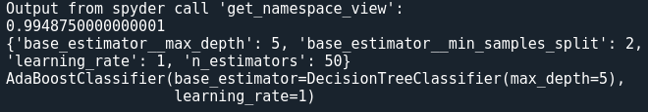

4. Training and testing procedure of the model on Kaggle:

At first, I use Adaboost with SVM and the original 4 features to do the classification task on Kaggle, in addition, I take log of the data and do standard scaling in order to avoid the inaccuracy caused by the inconsistency scale of values among different attributes, the classification accuracy on the training set is about 99.50%. The hyperparameters are as follow:

SVC(C=5, gamma=2.5, kernel='poly') ,n_estimators=100, learning_rate = 0.1.

For the classification task I submitted on Kaggle, in addition to the original output of the model on the testing dataset, I have a look of feature 4 on the testing dataset. From the label generated by the model, there’s a threshold of 28-30 on feature 4, in order to distinguish the label of the sample. However, I find that when feature 4 equals to 13-14 in the testing sample, there’s an obvious flaw of the original model, which classify the datapoints wrong, then I correct the nearly 15 points by hand, which is known as a threshold-based method to make the final Kaggle submission to be the accuracy of 100%.

5. Pseudocode of the whole algorithm:

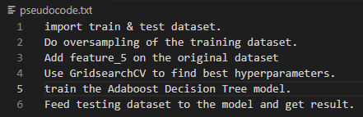

6. Performance of the model on the additional dataset:

On additional dataset, I use Adaboost with Decision Trees to classify the data, whose hyperparameters are stated at Part 3 in the report. Also, the result is attached in the compressed file, please check.